BART Ticket Vending Machine –

I can relate to the notorious interface of the BART vending machine. I travel to San Francisco every day from Fremont by BART and there are often people who are new to BART asking for help to get tickets. These people would usually include old people who would not understand the correct directions to follow and how much money it would cost.

Components of BART Ticket vending machine –

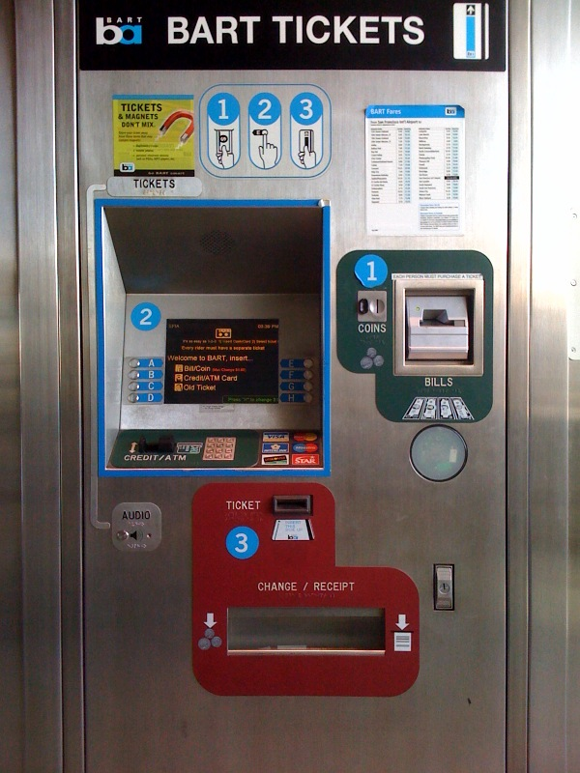

The four components of the BART vending machine includes the Bills, Coins and Clipper slot, the ticket and change/receipt slot and finally the screen along with the credit/ATM slot. The Screen can be interacted with using the eight buttons on either side of the screen. The eight buttons have arrows pointing to the options displayed on the screen. Another method would include the number keypad. The keypad also includes ENT and CANCEL button that depicts Continue or Cancel options. The credit/ATM slots accept the different types of cards indicated on the right side of the keypad. The coins’ slot accepts 5 cents, 10 cents and 25 cents. The Bills slot accepts $1, $5, $10 and $25. There is a circle that scans clipper card on touch. The ticket slot accepts old tickets and the same slot is used for dispensing new tickets. The Change/Receipt slot returns change as coins and receipts. The additional option here is the Audio option. This Audio feedback is useful for users who are blind or have low vision.

Process to Buy A Ticket –

The initial step includes checking our current location and our destination in the BART Fares chart stuck on top of the vending machine. The BART Fares chart shows one-way and two-way fares and users can add the correct value of fare amount to their ticket.

The next steps include inserting an old ticket or touching the clipper card on the circle to refill, inserting a bill, coin or the credit/ATM to begin ticket buying process. Once any of them is performed, the next screen displays the amount inserted (which is defaulted to $20), the current ticket value and the change due (is any). This applies if cash was inserted. If credit/ATM card was used, different information is indicated.

The default amount that is inserted is $20. Users have the option to add $1, subtract $1, add 5 cents or subtract 5 cents. Users can use the buttons A, B, C or D to choose the intended option. After selecting the required amount, users can print the ticket. A confirmation massage follows. If the user proceeds, tickets come out of the ticket slot. If clipper cards are used to refill, the clipper card is scanned on the circle again. A message asking if users want a receipt follows. If the user chooses ‘Yes’, the receipt and any change is sent out of the Change/Receipt slot. Change is always in the form of coins. Bills are not returned as change.

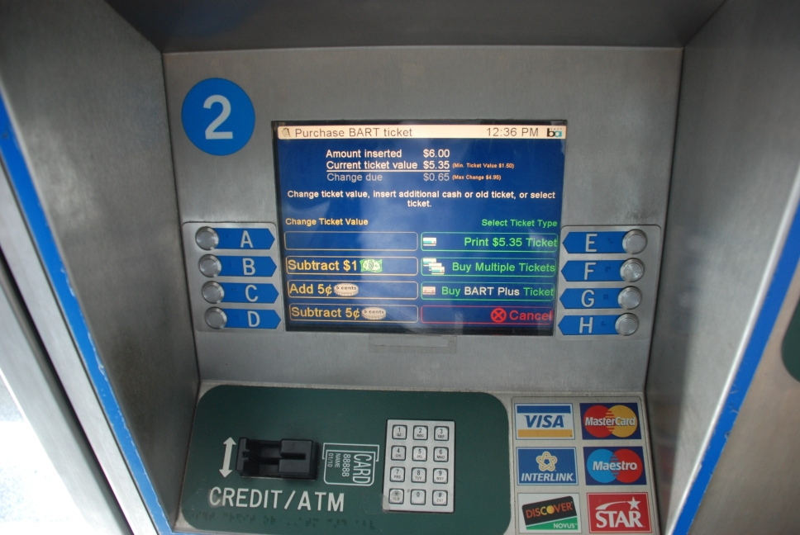

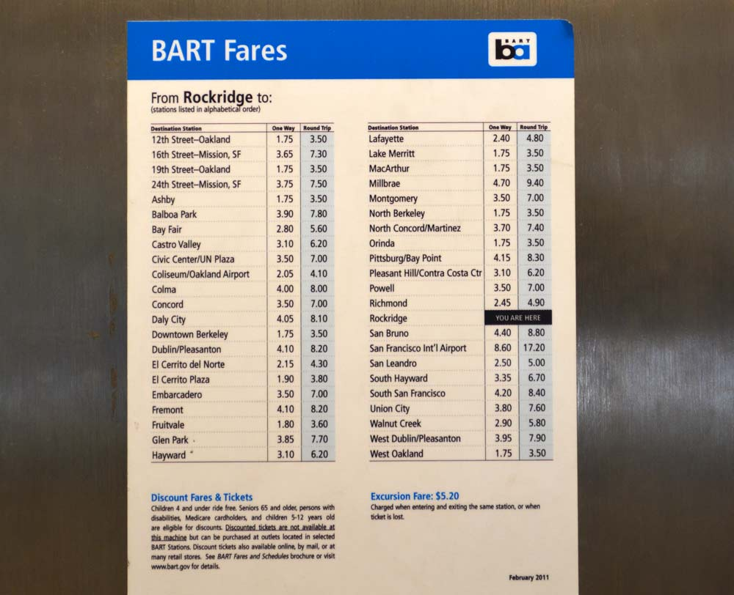

The difficult or ambiguous steps while buying a ticket include:

1. If user wants to insert a Credit/ATM card, the instructions provided to insert a card is not very clear. The side with the numbers face the top in the instructions but it does not clearly state if the numbers on the card should be facing us or away from us. Additionally, it does not clearly indicate how cards with chips should be inserted. The cards go into the slot however the user attempts to put it. The users is prompted to remove the card immediately. If the card is read successfully, the next step is shown. Otherwise, the users is indicated to retry but there are no instructions on what went wrong. The user will have to try all possible ways to insert the card before he/she finally succeeds. This is not a very effective approach especially during rush hours in BART. There can be long queues and if people take a long time to figure small things, the rest of the people in the queue and the person trying to get a ticket will be frustrated. Aged people or first time users will not know what is wrong. Some of them will think their cards are not accepted and will be at a loss of what to do. This can cause delays for them and the rest of the people waiting to buy a ticket.
2. The similar problem occurs for cash. Though it is obvious where to put the bills, some aged users will not know where to insert the bill. For example, there is a lot of space in the four sides of the bill slot and it is easy to mistake the bills can also fit in there. Obviously, the slot will automatically not accept bills here as in the correct bill slot, where it pulls the bill automatically. Yet some users will try to force the bill in the wrong place. Again, this is confusing for old users and this extra space can be closed or sealed to avoid this confusion.

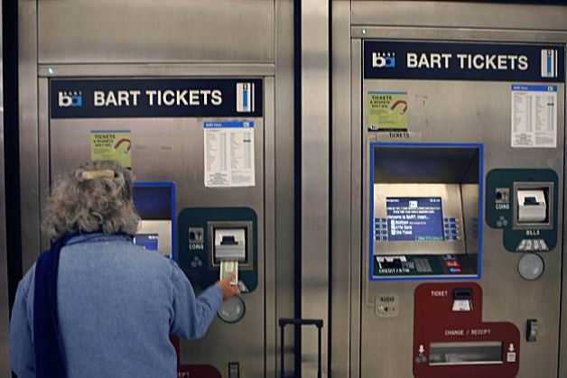

1. The Fare chart located above the Bill slot has very small font which makes it harder for people to read. Users will have to correspond the right ticket amount to the destination and add this value to their ticket using the buttons near the screen. It is easy to forget the price and users will have to look once or twice to confirm the price. In addition to this, since the font size is small, old people, users with low vision or people who are short in height will find it hard to read the text. It would be more efficient to select the destination on the screen and allow the computer to calculate the cost rather than the user having to do all the calculations. This can also be difficult for users who find it difficult to do math fast. For example, BART machines in busy stations such as Oakland International Airport have long queues. An aged user wants to buy two day two-way tickets to Fremont. The Fare Chart only shows one-way or two-way ticket fare. The user will have to mentally calculate how much it would cost for two days which could be difficult and time consuming and could get a lot of stares and sighs from people in the queue. If the machine was designed to calculate the cost on the destination, the number of tickets and the number of days, it would be easy for users to select the tickets for users.
2. Whenever ATM debit cards are used, the machine prompts users to enter a 4-digit PIN number. After entering the PIN number, users will have to press the ENT key on the keypad. When users are used to interacting with the eight buttons on either side of the screen for other selections, users will look for the ENT option on the screen before looking for it in the keyboard. This is a natural reaction and it would cause the user to look around for the option. Again this could disorient some users. Users would eventually find the button but it is not straight-forward. Each user should take an average of less than one minute to get their ticket and if it takes a user more time, they can cause a chain of delays for the other users.

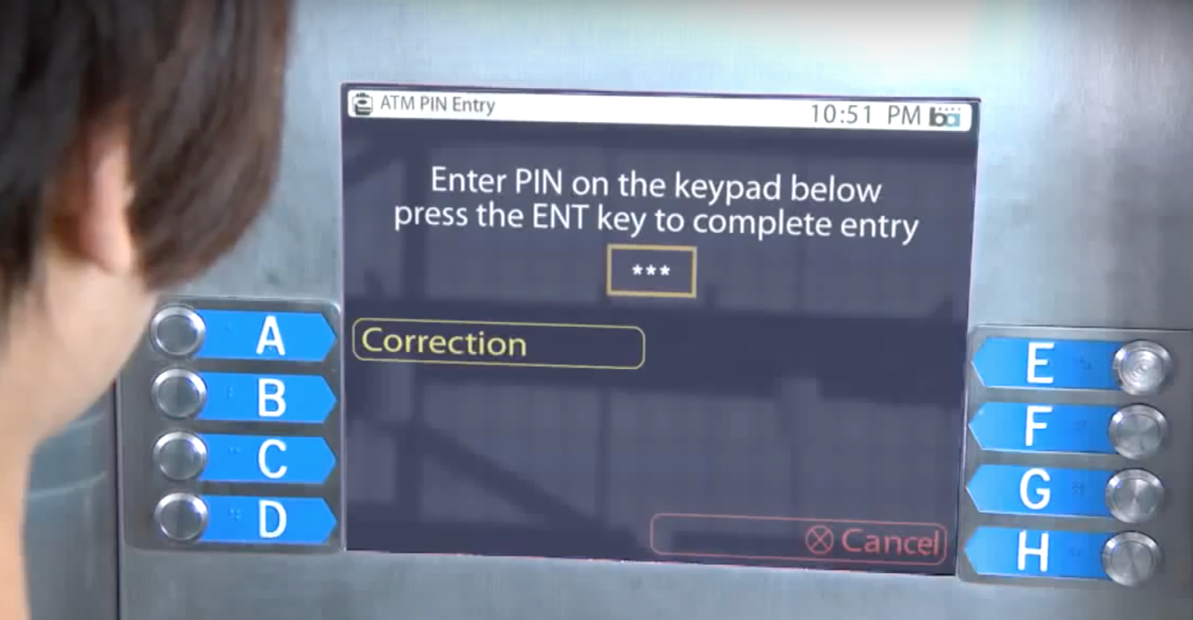

1. The amount of money that can be charged on a clipper card or an old BART ticket cannot exceed $40 per day. This instruction is NOT indicated anywhere near the vending machine. Users travelling by BART everyday would want to load their ticket or clipper card to with the fare amount for more number of days. Most often this would cost more than $40 and users will get error messages after making all the selections. This is frustrating because users will spend time entering all the information just to know that the limit for the day is reached. Either this message can be indicated in the beginning when the card or ticket was scanned so users know before hand or the user is prompted with a message indicating the daily limit reached while adding value to the ticket. The message that is displayed currently only states that the limit is reached and does not indicate what the limit is. The user will leave questioning the amount and he is bound to do the mistake again. The limit is indicated in broachers available in the BART stations which no one reads. These broachers are placed away from the vending machine so users will not even know that these broachers are available. This is also because upon entering the station, most users will look for the ticket vending machine to proceed further and not look for information broachers.
2. The way the Change/Receipt dispenser was designed did not take into consideration the width amount of unused space. People usually leave their receipts in the slot and they remain there until someone takes it out manually. If another person wants to take his receipt, his receipt gets mixed with all the other ones, they don’t know which one belongs to them. They dispenser is covered by a plastic door that can be opened only by pushing. There is no instruction to tell this and users just have to discover it. Since most vending machine, that dispense snacks and drinks, have a similar dispenser, users are generally aware that they need to push to open the door (Knowledge in the Head). But it can still be improved as described below. Then, they either take all the receipts they can grab to sort out theirs later or they can leave their receipt there and it piles along with the others. This is inefficient and makes us do another unnecessary work. Another problem comes when users need receive change. Change is only returned in the form of coins. The coins fall in the dispenser where all the receipts could be piled up and since the dispenser is wide, coins are scattered and users have to swipe their hand across the whole slot inside to grab his/her coins. They would also have to grab the receipts because they could be all mixed together in the same dispenser.

What would make it efficient is for it to have two different slots to dispense receipts and coins and they should be the small enough to fit the receipt or the coins.

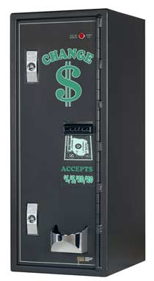

An example of a coin dispenser is shown above. The coins are collected in the bowl and users can easily take the coins out or leave them there if they wish. This way, receipts and coins are not mixed up and coins do not have to be scattered across the dispenser so people have to search. The receipts can be collected from another slot or can be programmed to come out of from the same slot as the ticket. Having the receipt and the ticket come out of the same slot improves space, reduces the number of interfaces and also avoids receipts piling up. One technique can assure that receipts never remain in the slot. That is, if receipts are requested, they should always be returned before the ticket. Having the receipt returned first will force the user to remove the receipt and keep it or throw it in the near-by bin. Then the ticket can follow because users will never tend to leave the machine without the ticket.

1. The vending machine used to pay for parking is different from the one used to buy the ticket. They are usually located once the user gets into the platform entrance with his/her BART ticket. So users buy their ticket to enter BART outside this entrance and they pay their parking fee inside the entrance. Another interaction with a machine. This is extremely inconvenient and users generally do not know this unless they ask the information desk. Having the ability to select their parking spot and pay for parking in the same machine they buy their ticket will be more efficient and less time consuming. One possible reason for BART to have their parking payment machine inside the platform entrance is so that users who are not using the BART do not park their cars and not use the BART. That is, to ensure that all people who use the BART are people who pay for parking, BART keeps their payment machine separately and within the platform.
2. The screen that allows users to ADD $1, SUBTRACT $1, etc., are designed to accept only one click for every addition or deletion. That is, there is no long press to continuously add and subtract huge values. For example, if a user has to buy a $40 ticket, and the default value to buy a card shows $20, the user will have to press ‘ADD $1’ button 20 times to get his desired money. It would be more efficient if there was a long click function where users can long click till the reach the closest number and then press the button to individually add/subtract the value.
3. Another related problem to the above is to have to use the buttons to add and subtract individually. It would be more efficient if users can directly enter the amount using the keypad located below the screen. This is convenient and users do not have to press a lot of buttons and can insert the amount directly.
4. The keypad that is provided is useless and is hardly used during the ticket buying process. The only time when a user would use it is to enter the PIN number for ATM cards.

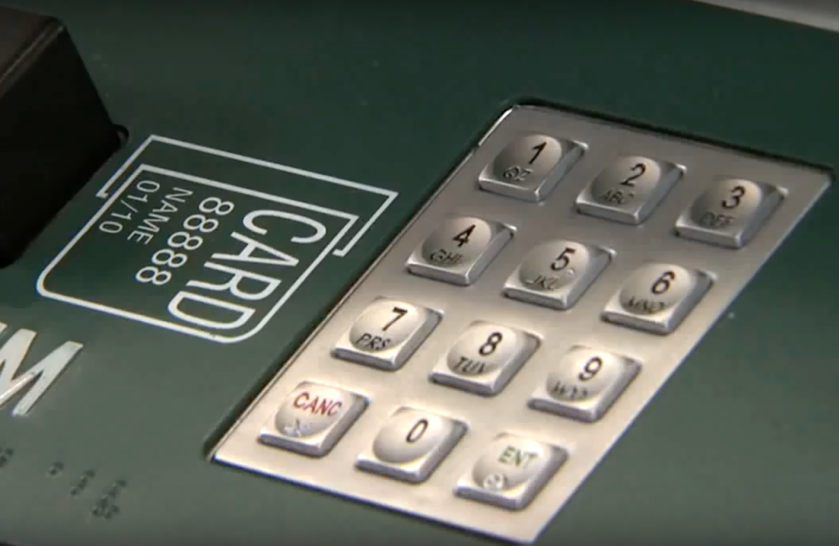

If people used cash or credit cards, they would not need to use the keypad at all.

1. The last but important point user interface problem is relating to the labels on the vending machine. Since thee vending machines are quite old, the stickers on these vending machines are old or faded. It is not clear what the instructions are if the stickers are not clear. For example, the Clipper card scanner is faded, users will not know where to place the clipper card to scan.

Summary –

There are a lot of improvements that can be made in terms of the user interface. Touch screens, intuitive and simple interfaces can replace the old, complicated and confusing interface. It is complicated because of the number of steps involved to get a ticket and confusing because it is always not clear the order of steps to follow. The drawback and the continuous engagement in these old systems is due to the restricted budgets for BART developments. The BART continuous to extend its stations and destinations while the old ones are left old and inefficient. Thousands of people use the BART to travel every day and in order to let everyone get an efficient travel, BART can do simple improvements to better serve their users.